**1. Introduction**

**1.1 Purpose**

Agile based PDS, and open software mainly used for the systematic development of the product by creating modules and sub-modules on which a team of people are assigned and helps in developing the product.

**1.2 Document conventions**

This document clearly refers to the IEEE format and font “times new roman” font-size: 12.

**1.3 Intended audience and reading suggestions**

Intended audience who will get indulged with this product are the different sectors like- IT industry, film industry, designing companies, management companies, consultancy service companies, and mainly by software development firms and many more for maintaining the products development at different phases.

**1.4 Product scope**

Agile product development system in present scenario is gaining its popularity and the good thing about this is it doesn’t only consider software development, this can be used as a global software which will help in ease of communication and increase iterativeness.

This change will help more and more industries of any field to use this product and will facilitate better understanding of development to their customers and even their employees.

Suppose one software company got any contract from the customer for building up of any particular software and then this will work efficiently and help in manage the development of particular software by dividing the work in modules and giving that particular work to all the different departments present in the company’s organizational structure.

Some of the major changes in this technology are:

1. Collaboration and interaction over rigid rules and lines of authority.
2. Involvement of customers and other stakeholders in the development process.
3. Prototypes are given more importance than the documentation.
4. Ability to respond to change.

**1.5 References**

IEEE. *IEEE Std 830-1998 IEEE Recommended Practice for Software Requirements*

*Specifications.* IEEE Computer Society, 1998.

**2. Overall description**

**2.1 Product perspective**

Agile based PDS (Product Development system) helps in maintaining and dividing the things in organizational hierarchy. It is an interactive, user-friendly and a unique system with various different features which will help in forming the development timeline required for the completion of the product.

The use case diagram in figure 1 illustrates the external entities and system interfaces for release 1.0

**2.2 Product functions**

The main use of this system is that it helps in developing the organizational structure related to the development of the final product. It also provides an interface to the employees working under the PDT to input the further work progress of the modules.

The use case diagram in figure 1 depicts the major groups of related requirements and how they work out in a particular scenario.

**2.3 user classes and characteristics**

**Customer**

A customer is the actor who is defining the product specification to the

Manager/HRD, which in turn is defining modules for the product.

Customer can view the progress of his product and can suggest some changes which he requires to be done in the product.

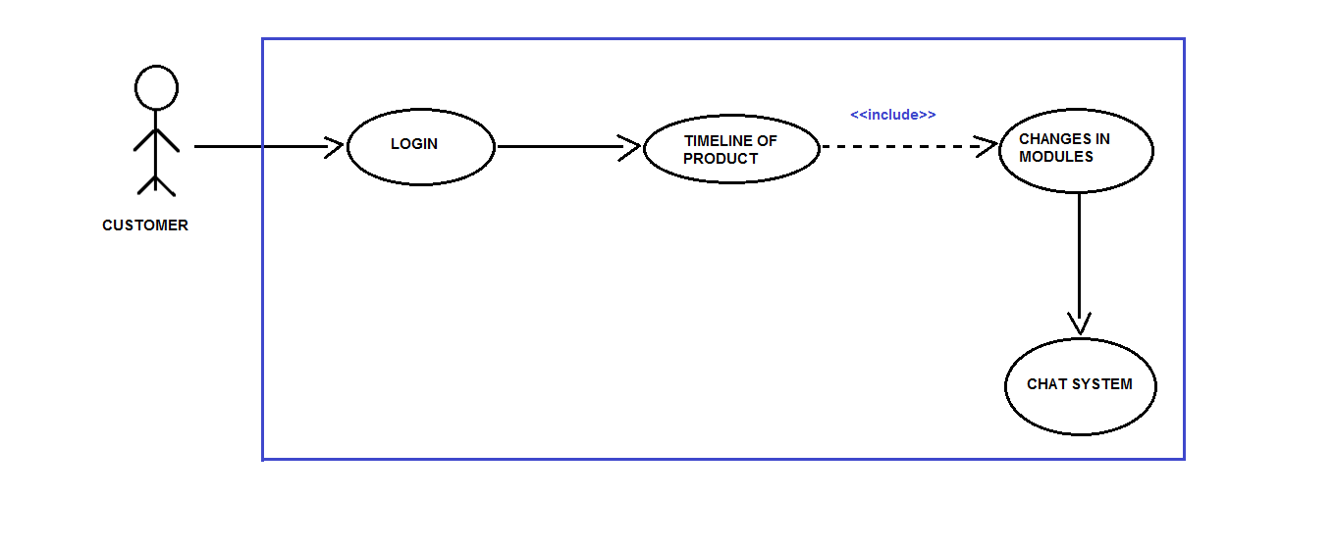

**Manager/HRD**

Manager/HRD is the actor who is responsible for the commencement of the product development phase, which he does using the system’s interface provided to him.

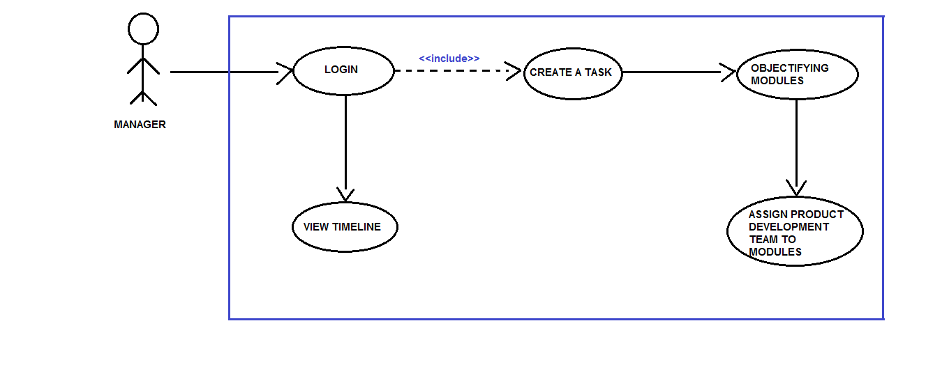

**Employee**

The employee working in the PDT is the actor who is responsible for the daily reporting on his assigned module by the Manager/HRD. He will be looking towards the changes required by the customer in the product and will help in maintaining proper product’s timeline on the weekly basis including updates, deletion or any modification done by them.

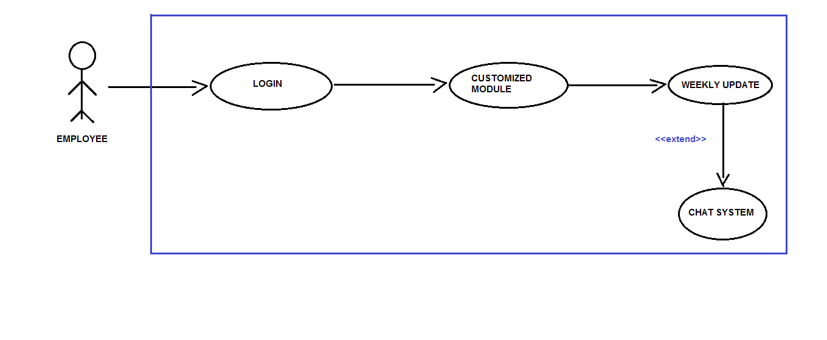

**2.4 Operating Environment**

E-1: The Agile-PDS shall operate with the following web browsers:

Microsoft Edge version-38 or latest, Google Chrome Version-53 or

Latest.

E-2 The Agile-PDS shall operate on a server running the current corporate

Approved versions of Jboss and Wildfly Web Server.

E-3 The Agile-PDS shall permit employee access from the firm’s intranet,

And if the employee is allowed for the outside access through the firm’s

Firewall, from an internet connection at employee’s remote location.

E-4 The Agile-PDS shall have a hosted interface on the internet for the

Customer.

**2.5 Design and Implementation Constraints**

DIC-1 The system shall use the current corporate standard of MySQL engine InnoDB.

DIC-2 The system shall use the current corporate standard of NoSQL with MongoDB.

DIC-3 All HTML code shall conform to HTML 5.0 standard.

DIC-4 All scripts shall be written in JavaScript’s.

DIC-5 The system’s design, code and maintenance shall follow the Eclipse Neon Java EE tools.

**2.6 User Documentation**

D-1 The system shall provide an online hierarchical and cross-linked help system

In HTML that describes and illustrates all system functions.

D-2 The first time customer when accesses the system, on demand it will be given

Information regarding the User Interfaces.

**2.7 Assumptions and Dependencies**

ASM1 The final product made by the firm is feasible according to their standards.

DEN1 The operation of Agile-PDS depends on the firm’s Manager/HRD who is

Responsible for the creation of the task and defining its modules, later

Assigning it to the product development team.

DEN2 The operation of Agile-PDS depends on the employees working in product

Development team inputting their work progress which helps in framing the

Timeline of the final product.

DEN3 The operation of Agile-PDS depends on the customer in regular

Commentation and communication about the final product’s modules/goals.

**3. External interface requirements**

**3.1 User Interfaces:**

UI 1: The XYZ screen will display a login page with a drop box, where there can be three different types of personnel’s entering their respective **username and password**.

UI (Customers): The customers can see the progress and the timeline for the respective project. Also there will be a **chat system,** if there are any messages for any of the teams, the same can be conveyed through the chat system.

UI (Manager):   The manager/HRD can create a new project, set the modules, assign teams to these modules and specify the timeline within which all this work is supposed to be done.

UI (Development team): The personnel in the Development team can update their project progress/report, time to time. They can also send and revert messages through the **chat system**, if needed.

**3.2 Hardware Interfaces:**

No hardware interfaces have been identified.

**3.3 Software Interfaces:**

SI1 Chat System/Commenting Service.

SI1.1 Chat System is responsible for sending the comments provided by the

Customer to its designated employee working on that particular module.

SI1.2 Chat System can also be utilized by the employee in clearing its objectives

While designing/implementing its module.

**3.4 Communication Interfaces**

CI-1 When the task is fully created an email should be sent to the customer with detailed information about the modules.

CI-2 The Agile-PDS should send an email to the customer to report any problems

With the modules (objectifying goals).

**4. System features**

**4.1 Creating a task**

**4.1.1 Description and Priority**

Agile PDS whose identity has been verified and is right now one of the most stable platform for the development of any product or software. Its main purpose is to ease and fasten the communication link between the manager and employees, employees and customers.Priority = High.

**4.2 Functional Requirements**

|  |
| --- |
| **task.name**: The name of the task must be decided and shall be posted by manager whenever he wish to create his new task and shall be shared among the PDT.  **Task.customer_name:** the name of the customer who has given the task must be written while creating the modules.  **Task.company_name :**name of the company to which customer belongs shall be provided. |
| **Task.create_modules :** manager shall create the modules based on the product specification which that company requires.  **Task.assignment _of_product_to_PDT :** Manager shall assign the task as per the specification of the team. |
| **Task.timeline :** Basically this will let customer to see the whole levels that till what stage the product is finished and which team is currently working at that moment.  **Task.changes_in_modules :**  Customer shall ask for some changes if its not according to his requirements.  **Task.chat_system :** Using this chat system customer can give update about the changes whether it's okay or not and relating to his response the team can look after that query. |
| **Task. Customized _module :** employee shall work on the allotted module related to his profile.  **Task.weekly_update:** employees should weekly update the modules on the basis of the **Task.chat_system** according to the customer requirements. |

**4.2 Modify, view, create and delete task**

**4.3 Creating a module**

**4.3.1 Description**

Creation of modules on the basis of customer requirements is done by the manager and during this process he assigns them to the product development team, according to their field of work or the field which suits the particular employee best.

**4.4 Modify, view, delete and create module**

**4.5 Assigning modules to PDT**

**4.5.1 Description**

During this phase of development when all the modules are created and designed then the team assigned to the modules will work in the development process of that product. This team will also help in modifying the product to the changes required by the customer which he will put in the chat box and will be done on weekly basis.

**5. Other non-functional requirements**

Performance tester of the program would be involved from the initial stages of planning. The non-functional requirements includes continuous feedback to developers, architects and system analysts and at the same time it will help in sharing the test assets across the projects and versions.

Our main goal is to reduce the effort during the development of the product and test put the performance and functionality in the same time frame, so as to reduce the time complexity and capital required to incorporate changes and produce a customer satisfied product.

**5.1 Performance requirements**

**Real Time Tracking:**The system would track the progress of all of the efforts that are being put into the project in real time.

**User Friendly Environment:** The system will be fairly basic and user friendly so that it can be maintained by those having a comparatively less technical background.  
**Grievance Redressal Mechanism:** The system would take the inputs from users and beta-testers as soon as the project is deployed, so if any user reports a bug or an issue, then it can be rectified then and there itself.

**5.2 Safety Requirements**

**Periodic Backups/Recovery:** In case if any situation arises where the data is being completely lost, we will ensure that a backup of the entire project is taken into the server, preferably the Cloud, beforehand. The recovery of this data will be done in an order to reduce the time and effort of the firm. This backup will be done periodically such as weekly or on a monthly basis, depending on the requirements of the firm and the volume of data being generated during this process.

**5.3 Security Requirements**

**Preventing Data Leakage:** There would be a strong requirement to secure the data and protect the privacy of the users as well as the developers at the same time.So a strong need would arise to protect the huge amount of data from being destroyed or manipulated by malicious users such as black-hat hackers and crackers.

**5.4 Software Quality Attributes**

**Availability:** The system will be available to the users as well as the developers anytime during the day, so as to view their progress report.  
**Consistency and Reliability:** The system will be designed to become consistent and not fail at any given point of time, even if it does then we will have counter measures to rectify the system, then and there itself.

**5.5Business Rules**

* We would be open to implement changes at any given instance of time, whether the project is in its initial stages or the final stages.
* Everyone involved in this project, be it the business people or the developers will work together daily throughout the project, this in turn will not only help us achieve our goals earlier but more efficiently as well.
* Regular meetings will be held to discuss the prospects of improvement at any stage of the project and choosing the right pace for the team members